MORE OR LESS
KS1 – 2005 Paper 1
1.
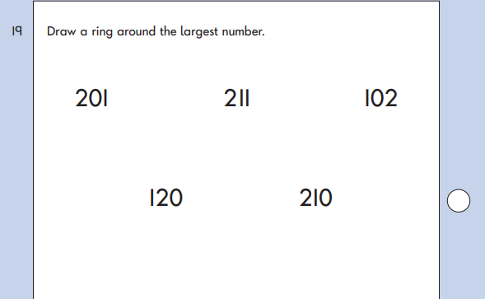
KS1 – 2007 Paper 1
2.
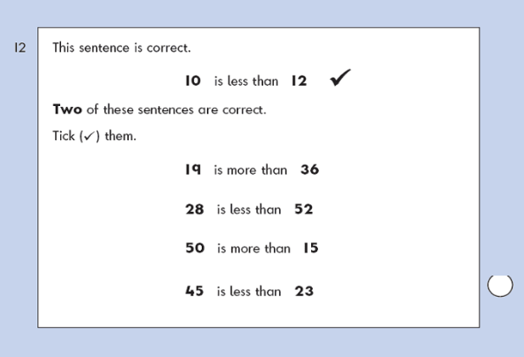
KS1 – 2009 Paper 1
3.
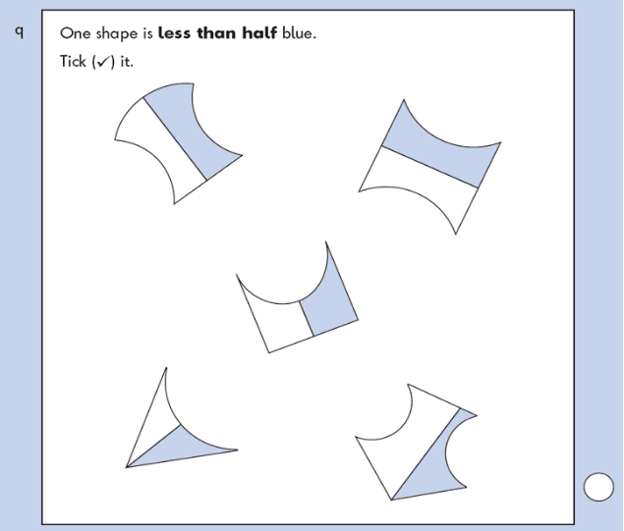
KS1 – 2009 Paper 1
4.
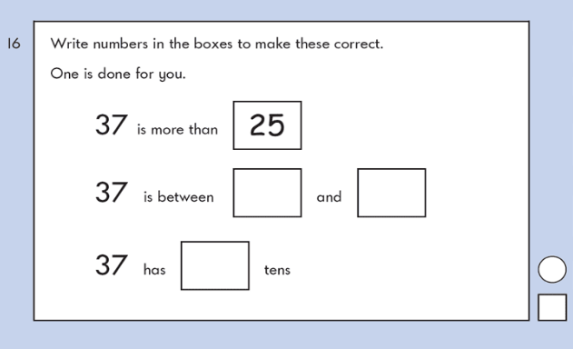
KS1 – 2016 Paper – Reasoning (Second)
5.

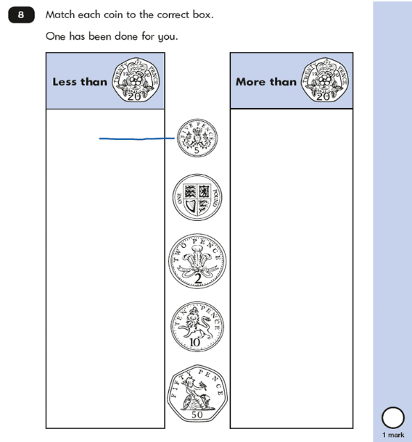
KS1 – 2017 Paper – Reasoning
6.

